Quality Enhancement Cell- KUM was established, with a mandate to implement Quality standards and processes of HEC, ensuring academic standards through the conduct of different surveys /assessments and providing feedback to the institutional departments for their future actions. QEC, on the basis of Quality processes, receives feedback and suggests certain suggestions/recommendations to institutional management for consideration and action.

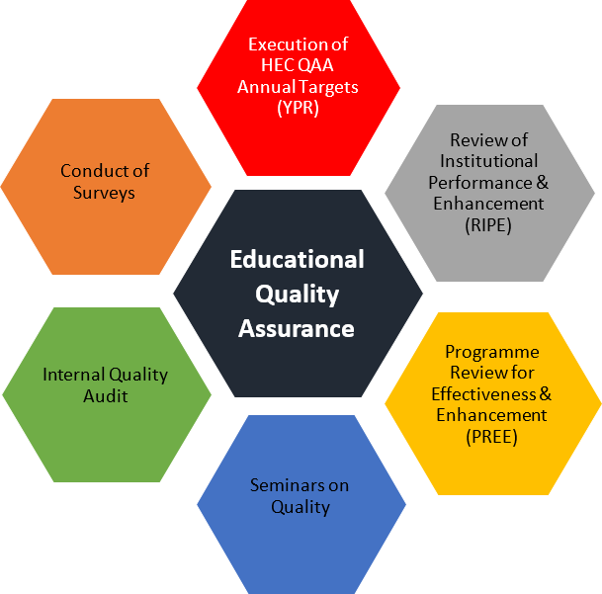

Kohsar University Murree (KUM), through implementation of these set QA standards/guidelines, develop professional knowledge, competencies and employable skills of its graduates, enabling them to contribute effectively in the job market. QEC, through quality interventions, extends its support to the departments in improving standard of their teaching‐learning and research enabling its compatibility with other national and international HEIs. QEC intends to ensure, through the implementation of QA practices, the production of competent graduates, equipped with the requisite knowledge and skills as per the requirements of the existing job market.

QEC Vision
To establish Kohsar University Murree as a globally recognized, top-ranking institution by developing an agile and efficient environment that promotes global best practices. Our goal is to create a collaborative network where every stakeholder is empowered to achieve excellence.

QEC Mission
To provide exceptional education by continuously improving a supportive and dynamic learning environment that fulfills the needs of students, professionals, and the community through:
- Facilitating coordination, collaboration, and the exchange of quality-driven initiatives among all stakeholders.
- Enhancing impact by integrating and applying best practices to create meaningful value.
- Ensuring fairness and consistency through the ongoing monitoring, assessment, and evaluation of all stakeholders

